TIES 452 (2013): Guidelines for the 4th computer class demo
Your surname: Edris
Your first name: Aman

Task 1: Prepare CWM environment
- Find out where Python is installed. Likely locations:
  - c:\Python27
  - c:\MyTemp\Python27
- If you don’t have Python installed, install it (e.g. into c:\MyTemp\Python27).
- Add the python folder into your PATH variable. Example:
  - set PATH=%PATH%;c:\Python27\
- Now you should be able to run python from any folder. Open command line. Go directly into c:\. Test python by running:
  - python --version
You should see the version of python. If not, something went wrong.
- Download CWM from http://users.jyu.fi/~olkhriye/ties452/demos/demo4/cwm-1.2.1s.zip and unpack it into a folder of your choice (e.g. into c:\MyTemp\CWM).
- Open command line. Go into CWM folder. To check if CWM is working run:
  - python cwm --help
You should see a long list of commands and options for CWM.

Task 2: Try out forward chaining reasoning in CWM (via N3 rules) and Protégé (via SWRL rules).
- Download RDF data from http://users.jyu.fi/~olkhriye/ties452/demos/demo4/dataNew.n3 (the data is in Notation3) and RDF data from http://users.jyu.fi/~olkhriye/ties452/demos/demo4/dataNew.owl (the data is in Notation3 to be used with Protégé 4.x).
- Prepare a file called rule.n3. This file will contain your rules in Notation3 (using N3 logic).
- Create the rules below in both languages (N3 and SWRL). Run CWM reasoner for each rule separately and for each rule provide the output of reasoning. Apply SWRL rules in Protégé and provide correspondent screenshots of the results.

Tip: You might need some special built-in constructs of N3 logic and SWRL rules.
Look here: http://www.w3.org/2000/10/swap/doc/CwmBuiltins
Look here: http://www.daml.org/rules/proposal/builtins.html#8.1
example
Property ex:hasChild has an inverse property ex:hasParent.
Make a rule that creates inverse statements of statements having ex:hasChild as their predicate.
N3 Rule(s)
@prefix ex: <http://www.smith-family.com/familyOntology.owl#> .
{?x ex:hasChild ?y} => {?y ex:hasParent ?x} .
Result of CWM
c:\MyTemp\Programs\cwm-1.2.1s>python cwm data.n3 --filter=rules.n3
#Processed by Id: cwm.py,v 1.197 2007/12/13 15:38:39 syosi Exp
# using base file:///MyTemp/Programs/cwm-1.2.1s/data.n3
# Notation3 generation by
# notation3.py,v 1.200 2007/12/11 21:18:08 syosi Exp
# Base was: file:///MyTemp/Programs/cwm-1.2.1s/data.n3
@prefix : <#> .
@prefix ex: <http://www.smith-family.com/familyOntology.owl#> .

:alice ex:hasParent :jane,
:mark .
:bill ex:hasParent :alice,
:andy .
:charles ex:hasParent :dana,
:harry .
:harry ex:hasParent :alice,
:andy .
:john ex:hasParent :bill,
:kate .
:mary ex:hasParent :bill,
:kate .
:robert ex:hasParent :dana,
:harry .
#ENDS
SWRL Rule(s)
hasChild(?x, ?y) -> hasParent(?y, ?x)
Result of Protégé
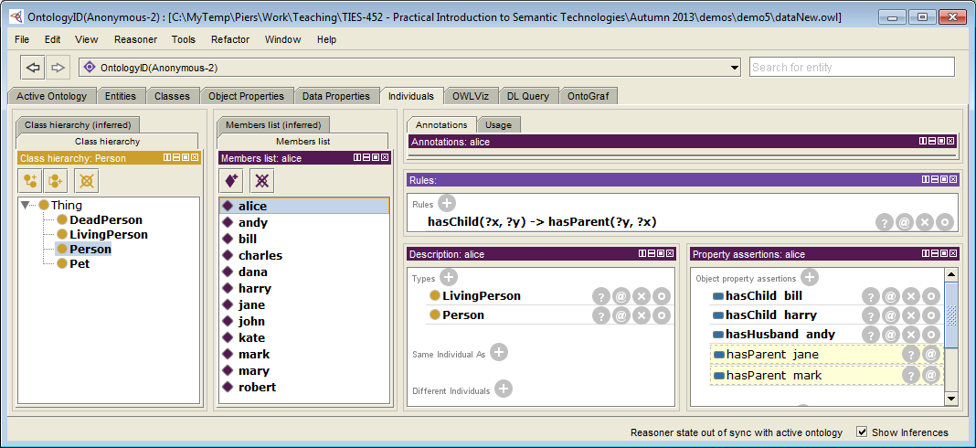
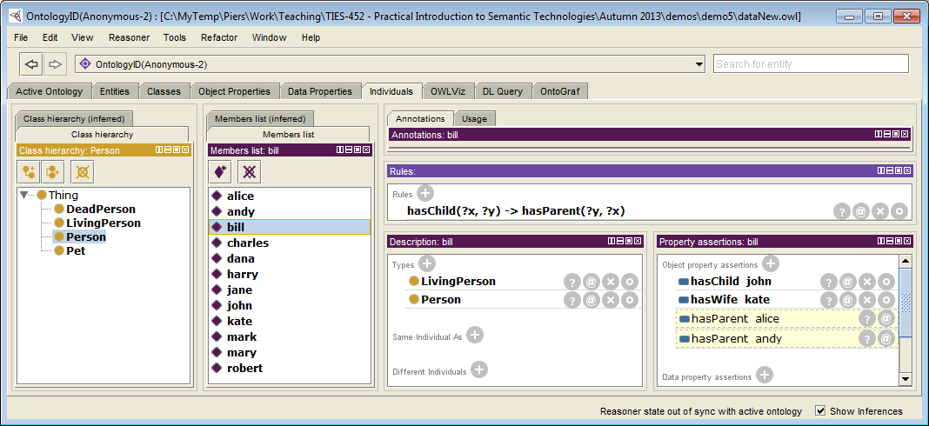
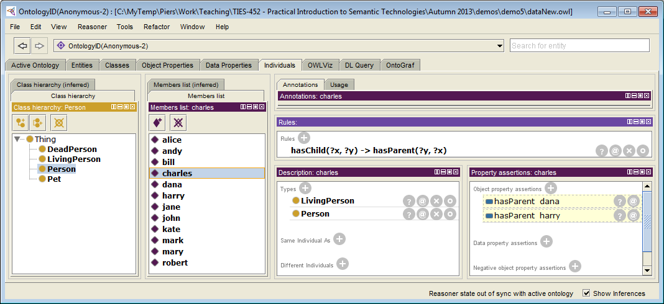
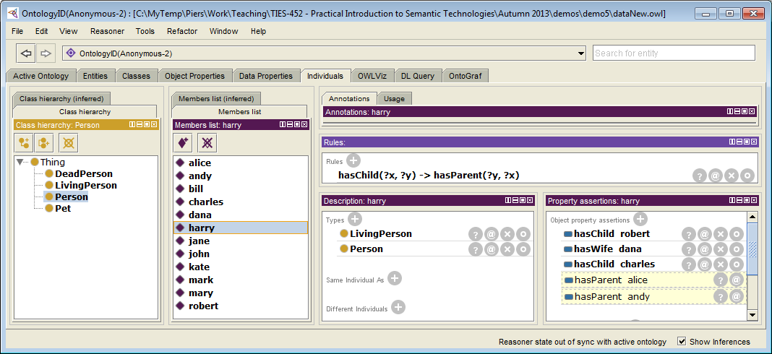
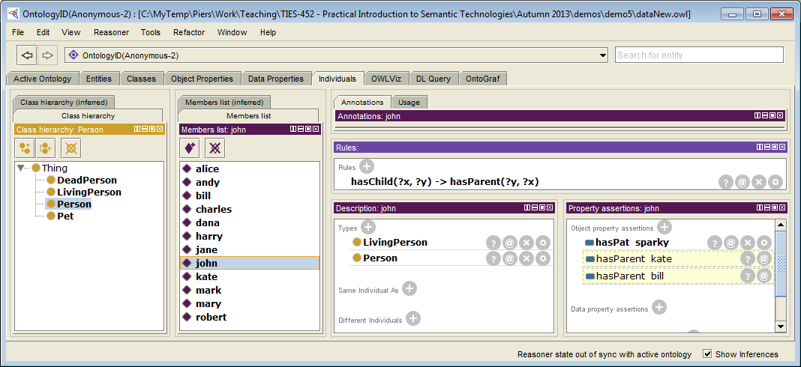
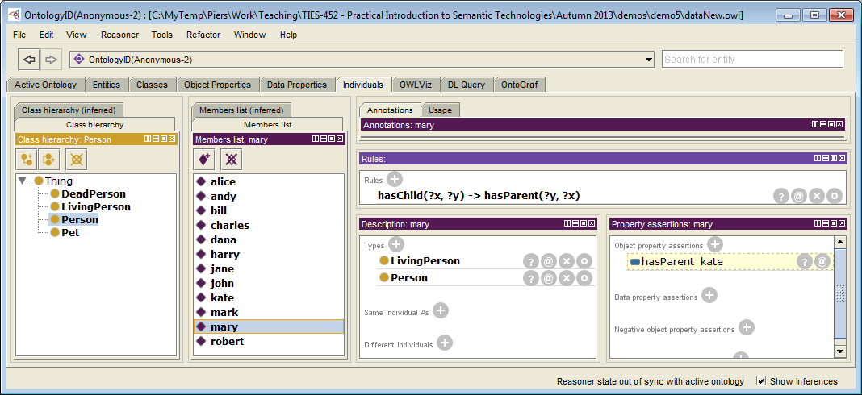
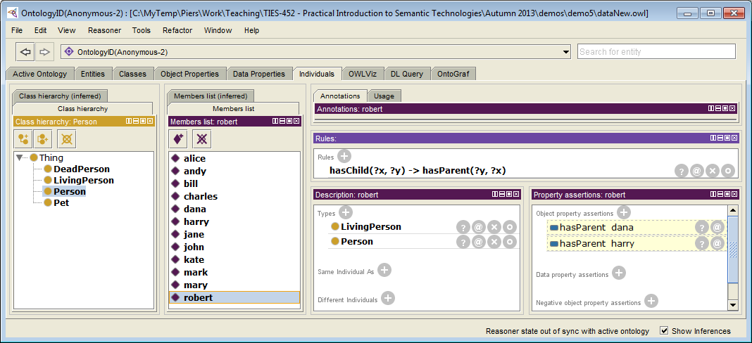

Q1: An individual belongs to class ex:Widow if and only if that individual has a husband that is dead.
Having husband is expressed using property ex:hasHusband.
Dead person is a person that belongs to class ex:DeadPerson.
Make a rule that annotates all widows.
Rule(s)
@prefix ex: <http://www.smith-family.com/familyOntology.owl#> .
@prefix rdf: <http://www.w3.org/1999/02/22-rdf-syntax-ns#> .

{ ?x ex:hasHusband ?y. ?y rdf:type ex:DeadPerson} => { ?x rdf:type ex:Window }.
Result of CWM
edriss-MacBook-Pro:cwm-1.2.1s edris$ python cwm data.n3 --filter=rule.n3
#Processed by Id: cwm.py,v 1.197 2007/12/13 15:38:39 syosi Exp
# using base file:///Users/edris/Documents/Practical sematics /cwm-1.2.1s/data.n3
# Notation3 generation by
# notation3.py,v 1.200 2007/12/11 21:18:08 syosi Exp

# Base was: file:///Users/edris/Documents/Practical sematics /cwm-1.2.1s/data.n3
@prefix : <#> .
@prefix ex: <http://www.smith-family.com/familyOntology.owl#> .
:jane a ex:Window .
#ENDS
SWRL Rule(s)
DeadPerson(?y), hasHusband(?x, ?y) -> Window(?x)
Result of Protégé
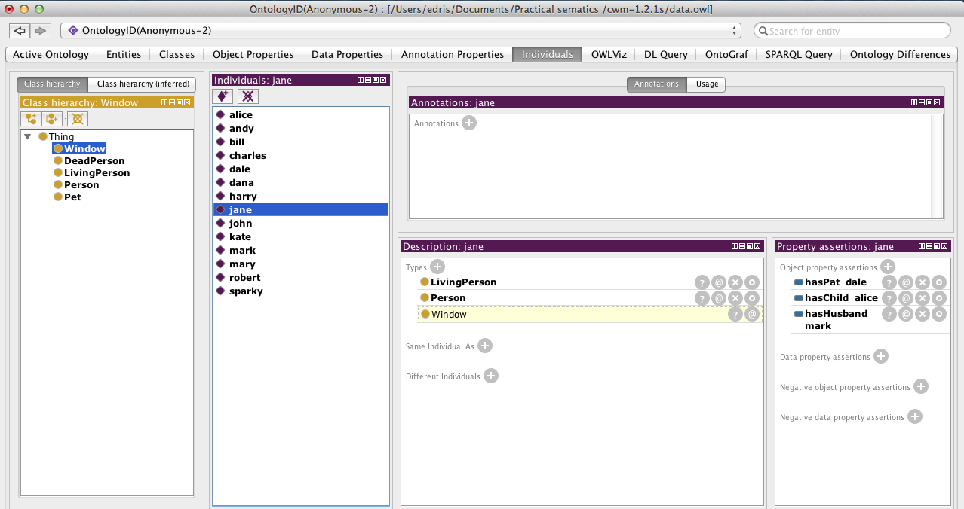

Q2: An individual belongs to class ex:PetLover if and only if that individual has a pet.
Having a pet is expressed using property ex:hasPet.
Make a rule that annotates all pet lovers.
Rule(s)
@prefix ex: <http://www.smith-family.com/familyOntology.owl#> .
@prefix rdf: <http://www.w3.org/1999/02/22-rdf-syntax-ns#> .

{ ?x ex:hasPet ?y } => { ?x rdf:type ex:PetLover }.
Result of CWM
edriss-MacBook-Pro:cwm-1.2.1s edris$ python cwm data.n3 --filter=rule.n3
#Processed by Id: cwm.py,v 1.197 2007/12/13 15:38:39 syosi Exp
# using base file:///Users/edris/Documents/Practical sematics /cwm-1.2.1s/data.n3

# Notation3 generation by
# notation3.py,v 1.200 2007/12/11 21:18:08 syosi Exp

# Base was: file:///Users/edris/Documents/Practical sematics /cwm-1.2.1s/data.n3
@prefix : <#> .
@prefix ex: <http://www.smith-family.com/familyOntology.owl#> .

:jane a ex:PetLover .

:john a ex:PetLover .
#ENDS
SWRL Rule(s)
hasPat(?x, ?y) -> PetLover(?x)
Result of Protégé
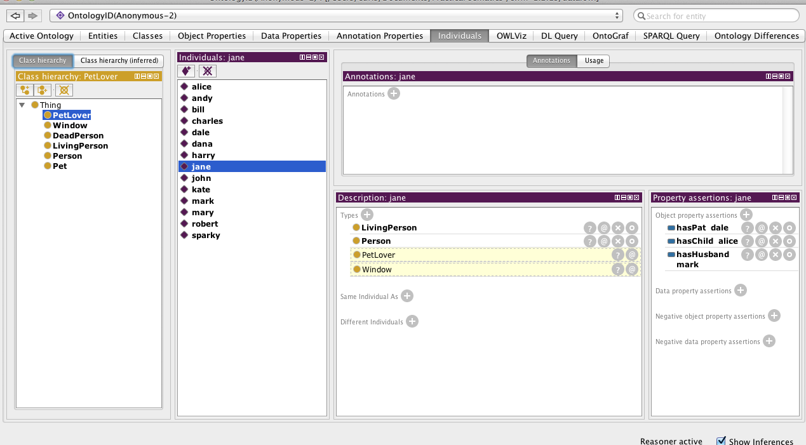
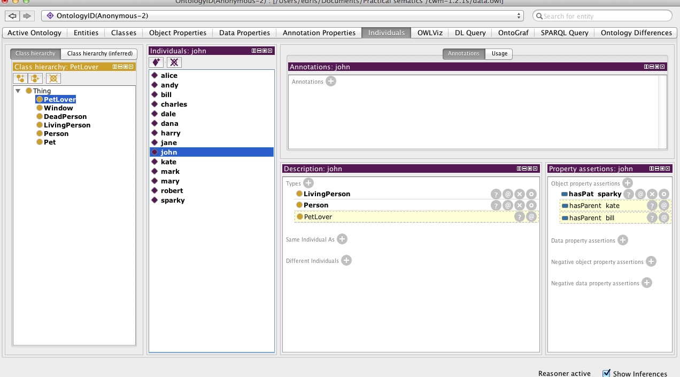

Q3: An individual belongs to class ex:Grandparent if and only if that individual has a child that has a child.
Having a child is expressed using property ex:hasChild.
Make a rule that annotates all grandparents.
Rule(s)
@prefix ex: <http://www.smith-family.com/familyOntology.owl#> .
@prefix rdf: <http://www.w3.org/1999/02/22-rdf-syntax-ns#> .

{ ?x ex:hasChild ?y. ?y ex:hasChild ?z } => { ?x rdf:type ex:Grandparent }.
Result of CWM
edriss-MacBook-Pro:cwm-1.2.1s edris$ python cwm data.n3 --filter=rule.n3
#Processed by Id: cwm.py,v 1.197 2007/12/13 15:38:39 syosi Exp
# using base file:///Users/edris/Documents/Practical sematics /cwm-1.2.1s/data.n3

# Notation3 generation by
# notation3.py,v 1.200 2007/12/11 21:18:08 syosi Exp

# Base was: file:///Users/edris/Documents/Practical sematics /cwm-1.2.1s/data.n3
@prefix : <#> .
@prefix ex: <http://www.smith-family.com/familyOntology.owl#> .

:alice a ex:Grandparent .

:andy a ex:Grandparent .

:jane a ex:Grandparent .

:mark a ex:Grandparent .

#ENDS-
SWRL Rule(s)
hasChild(?x, ?y), hasChild(?y, ?z) -> Grandparent(?x)
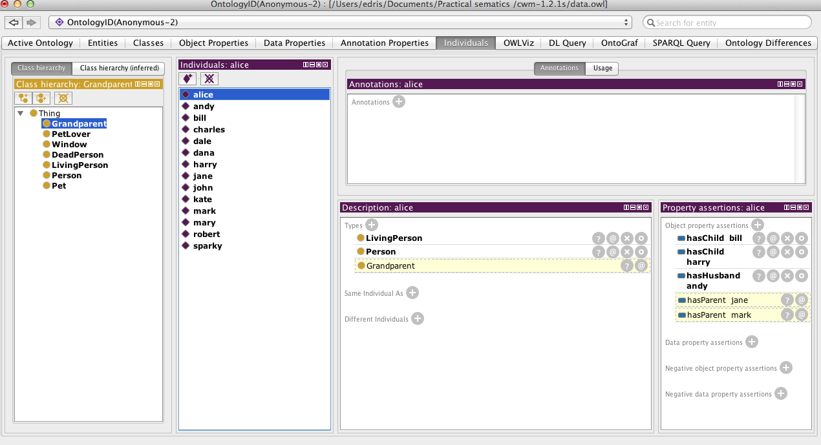
Result of Protégé
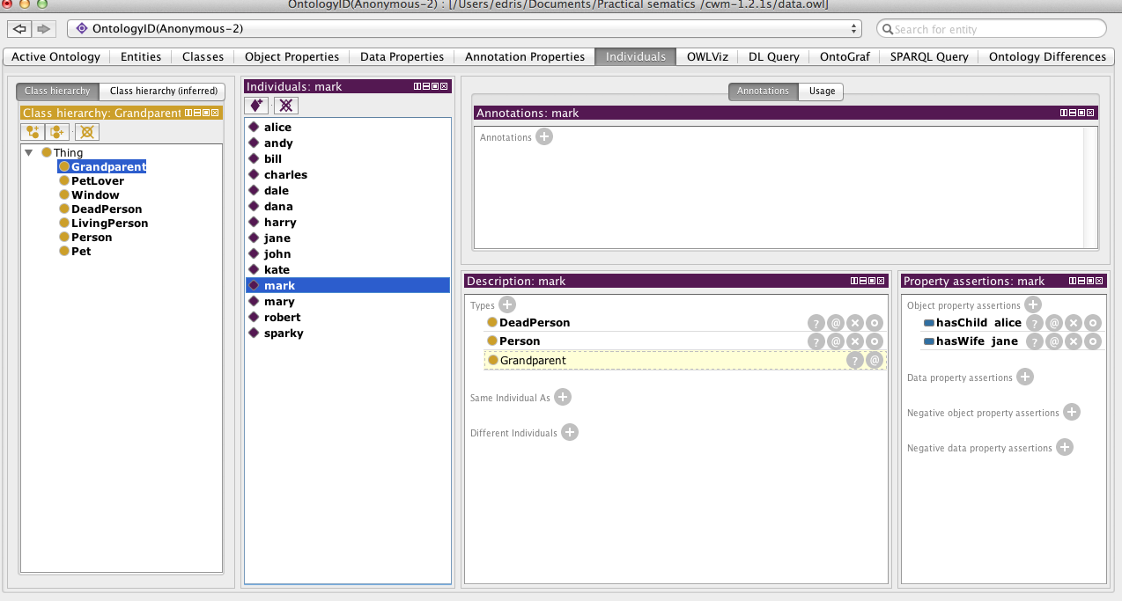
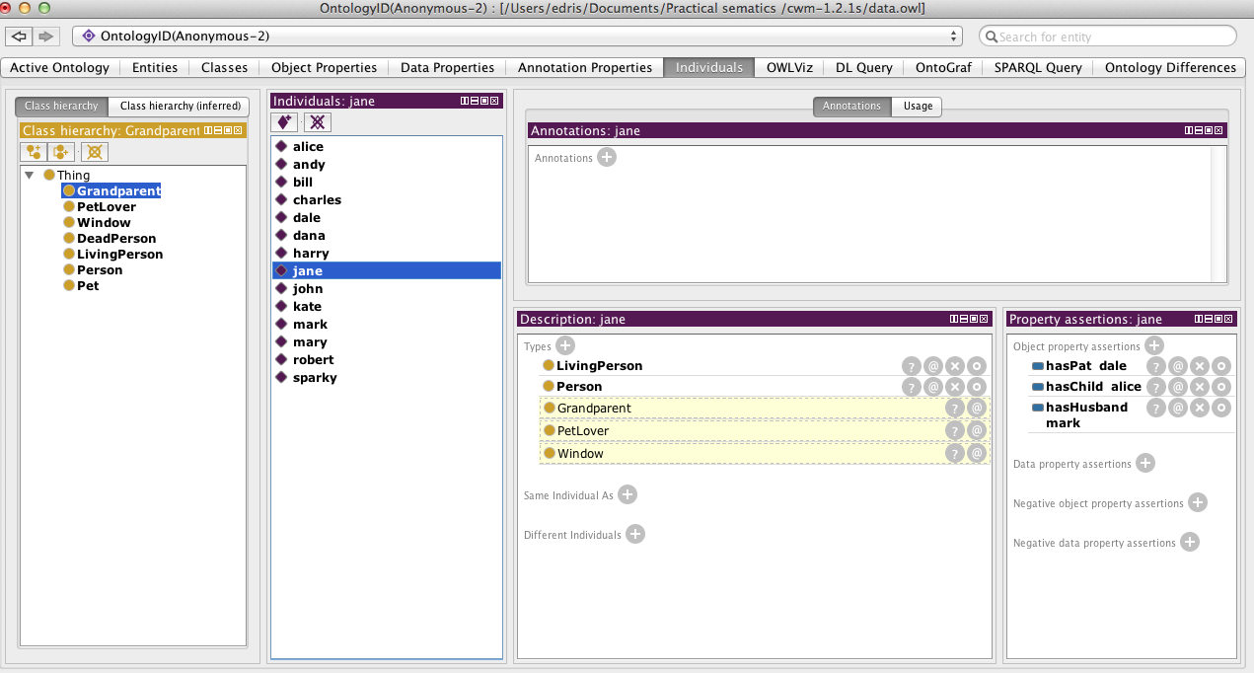
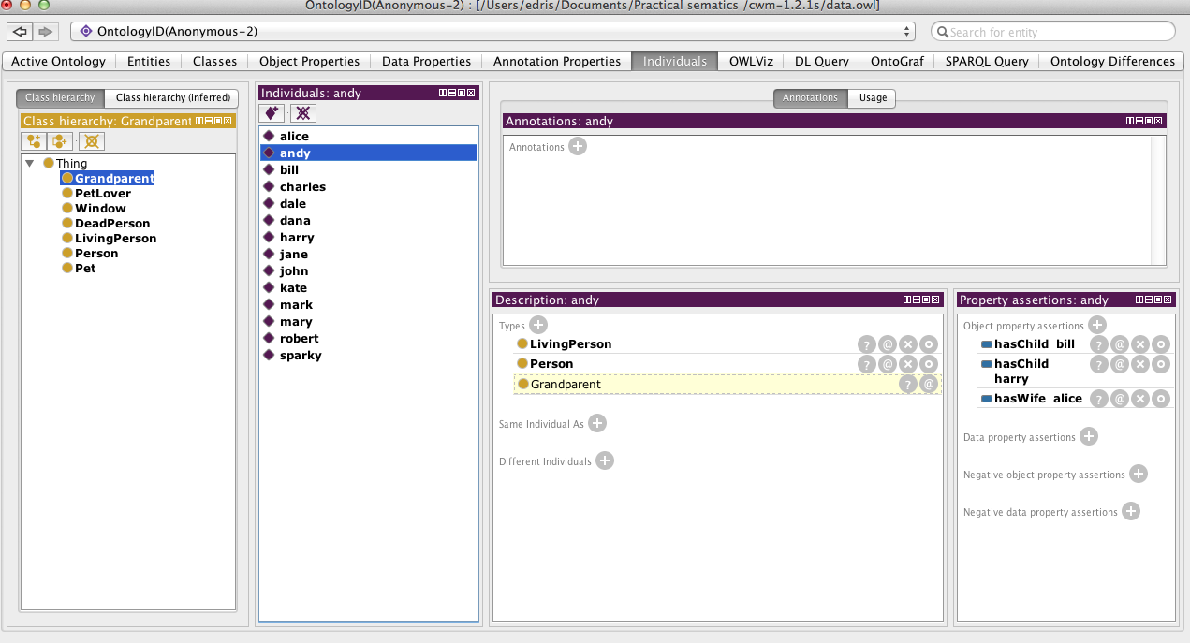

Q4: Connect all cousins with property ex:hasCousin.
Rule(s)
@prefix ex: <http://www.smith-family.com/familyOntology.owl#> .
@prefix rdf: <http://www.w3.org/1999/02/22-rdf-syntax-ns#> .
@prefix log: <http://www.w3.org/2000/10/swap/log#> .

{ ?z ex:hasChild ?x. ?z ex:hasChild ?y. ?x log:notEqualTo ?y. ?x ex:hasChild ?m. ?y ex:hasChild ?n. } => { ?m ex:hasCousin ?n }.
Result of CWM
edriss-mbp:cwm-1.2.1s edris$ python cwm data.n3 --filter=rule.n3
#Processed by Id: cwm.py,v 1.197 2007/12/13 15:38:39 syosi Exp
# using base file:///Users/edris/Documents/Practical sematics /cwm-1.2.1s/data.n3

# Notation3 generation by
# notation3.py,v 1.200 2007/12/11 21:18:08 syosi Exp

# Base was: file:///Users/edris/Documents/Practical sematics /cwm-1.2.1s/data.n3
@prefix : <#> .
@prefix ex: <http://www.smith-family.com/familyOntology.owl#> .

:charles ex:hasCousin :john .

:john ex:hasCousin :charles,
:robert .

:robert ex:hasCousin :john .

#ENDS
SWRL Rule(s)
-- paste SWRL rule here –
Result of Protégé
-- paste the screenshots from Protege here –

Q5: In case a person does not have a connection via ex:hasChild property to the individual that is connected via the same property with a spouse of that person (wife or husband), then build a connection between the person and individual via ex:hasStepchild property.
Rule(s)
@prefix ex: <http://www.smith-family.com/familyOntology.owl#> .
@prefix rdf: <http://www.w3.org/1999/02/22-rdf-syntax-ns#> .
@prefix log: <http://www.w3.org/2000/10/swap/log#> .
@prefix owl: <http://www.w3.org/2002/07/owl#> .

@forAll :x, :y .
{?a ex:hasWife ?b . ?b ex:hasHusband ?a} => {?a ex:hasSpouse ?b . ?b ex:hasSpouse ?a} .
{:y ex:hasChild :x . :y ex:hasSpouse ?b . <data.n3> log:semantics ?t . ?t log:notIncludes {?b ex:hasChild :x}} => {?b ex:hasStepChild :x} .
Result of CWM
edriss-mbp:cwm-1.2.1s edris$ python cwm data.n3 --think=rule.n3 --filter=rule.n3
#Processed by Id: cwm.py,v 1.197 2007/12/13 15:38:39 syosi Exp
# using base file:///Users/edris/Documents/Practical sematics /cwm-1.2.1s/data.n3

# Notation3 generation by
# notation3.py,v 1.200 2007/12/11 21:18:08 syosi Exp

# Base was: file:///Users/edris/Documents/Practical sematics /cwm-1.2.1s/data.n3
@prefix : <#> .
@prefix ex: <http://www.smith-family.com/familyOntology.owl#> .
:bill ex:hasSpouse :kate;
ex:hasStepChild :mary .

SWRL Rule(s)
-- paste SWRL rule here –
Result of Protégé
-- paste the screenshots from Protege here –

Files to include in the demo results:
- Demo4-instructions.doc (this file)
Send the demo results to lecturer (oleksiy . khriyenko @ jyu . fi) within 7 days after this Demo session.

